CSCI 2467
Lab 4

1. Write a program that asks the user to enter a number between 5 and 10 (include error checking) and uses that variable in a for loop. The for loop will ask the user to enter an integer and keep track of whether the integer is positive, negative or zero.

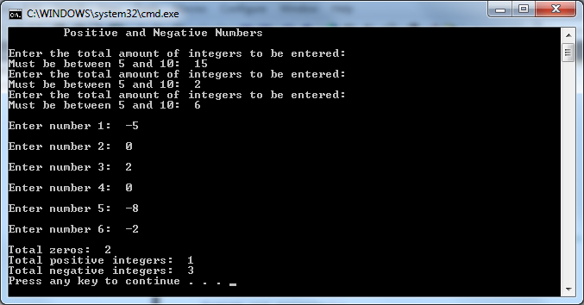
2. Write a program that reads a mix of positive and negative integers, finds the largest of them and counts its occurrences. Assume that the input ends with number 0. (Maintain two variables, max and count, max stores the current max number and count stores its occurrences. Initially, assign the first number to max and 1 to count. Compare each subsequent number with max. If the number is greater than max, assign it to max and reset count to 1. If the number is equal to max, increment count by 1.)

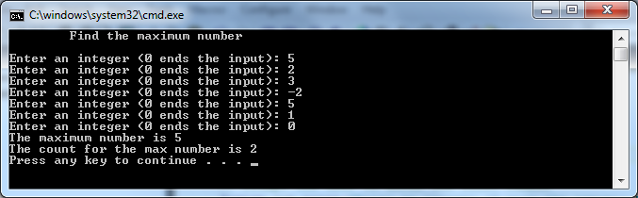
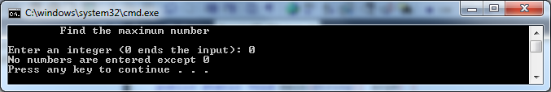

Submit both files via blackboard.

